**Meeting minutes with Loreal team**

**Date Time:** 29 Jan 2020, 4.00pm – 4.45pm

**Venue:** Loreal Office

**Attendees:**

Aldila SEPTIADI (data, digital ecommerce)

Vivian Quark

All members of FYP Team

**Discussion of Prototype of Dashboard**

Dashboard Sketches

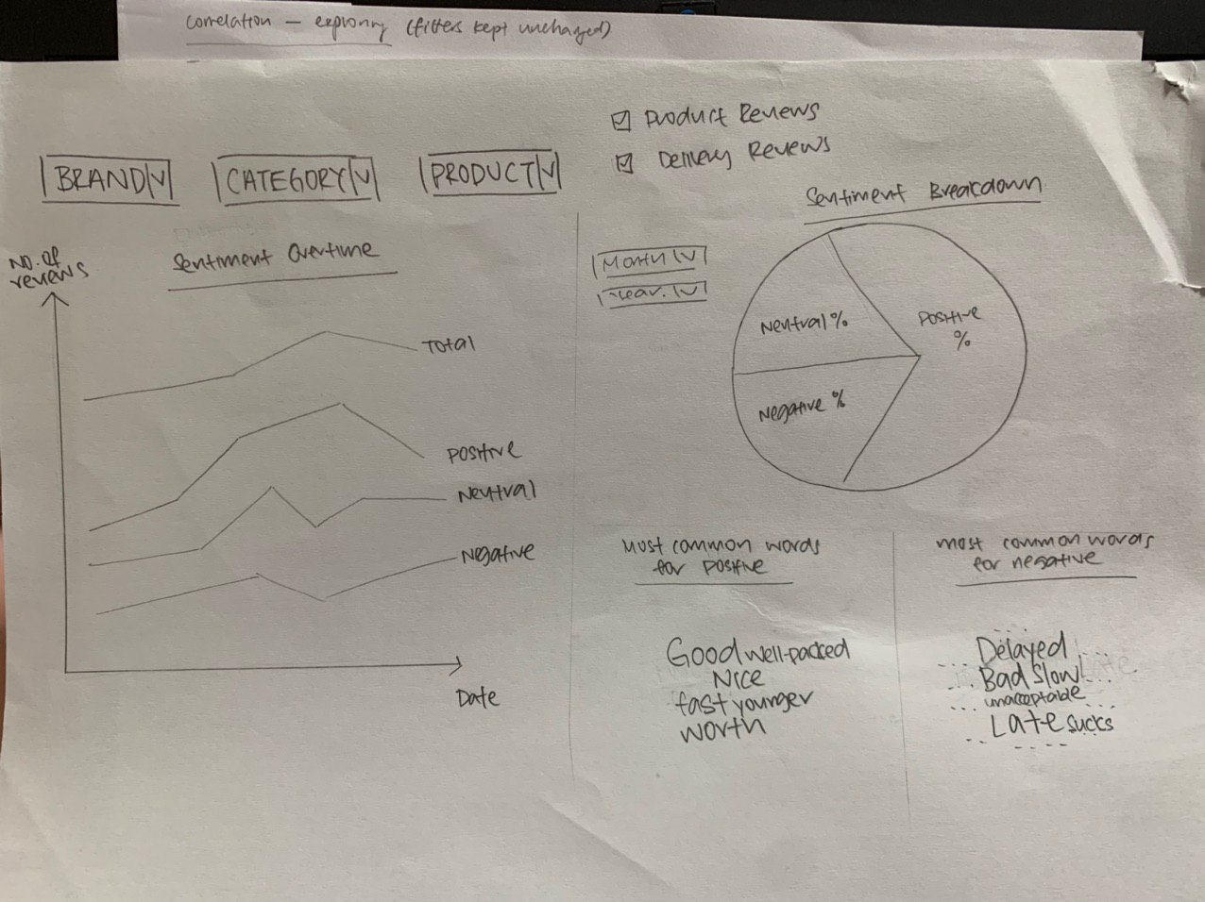

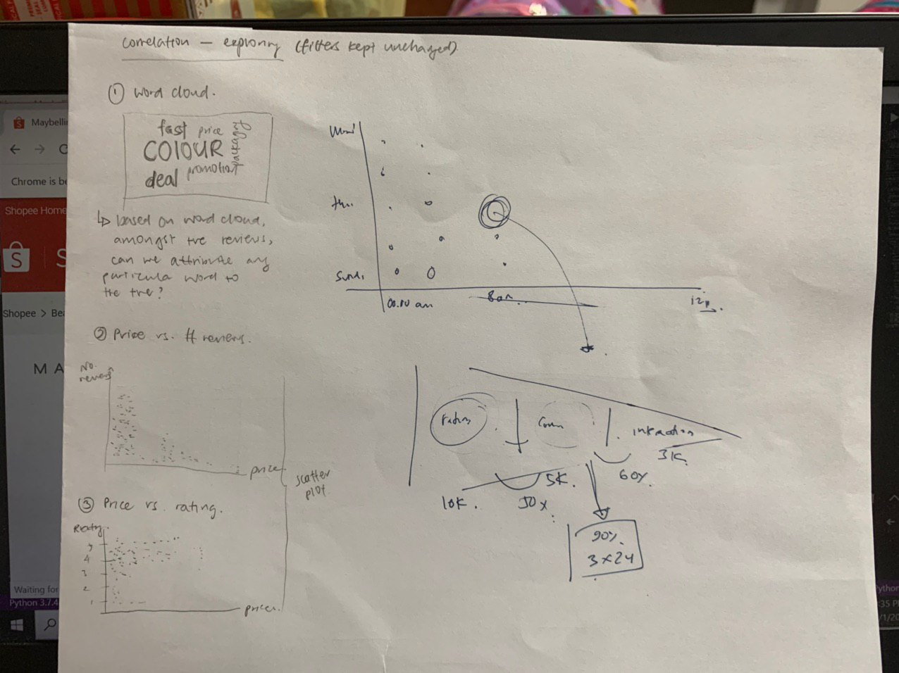

Discussion

1. Use heat map to visualise when is the peak period when most reviews are given and the Loreal response team can manage their manpower more efficiently

2. Find correlation of ratings, price and no, of reviews – 3D

3. Identify if the ratings match with the reviews (correlation matrix). For eg rating of 4 is considered normal rating (not considered a good rating). Try to match the reviews with the rating and see what the “normal” rating in the local market is.

Re-validate gaps. Quantitative (Rating score) should be supported by Qualitative survey (Feedbacks). Good rating, poor feedbacks?

Look into credibility, define your own formulas. Rating + Comment **OR** Rating w/o Comment. Which is more credible?

4. Price sensitivity of products – compare across competitors (hold until after midterms)

5. Timeline for number of reviews (year, month, week)

–can do for competitors of Loreal for event impact analysis (e.g. how promotion or price change impact reviews) (hold until after midterms)

6. Delivery: Classify the problems identified (identify pattern) e.g. damaged, late

7. Product:

- Identify Users commenting a lot times (> 5)

- Among the reviews commented how many is responded by loreal (funnel/ design up to us), to identify what is the response rate of Loreal Team (e.g. they should response to 90% of all reviews)

**Note on UI/UX:**

Left (most important) to right.

Filters:

Brand, Category, Date, Positive, negative, neutral

Identify main KPI of dashboard used

#Prioritize the UI:

- Consumers complaint about the products (make it eye catching)

**Others**

Relation between discount (Shopee cancel previous price) and sold quantity

Challenge and validate assumptions:

For example, Is it true that during discounted period, people leave negative remarks because there are limited stocks and they did not manage to get it.

Running Discount 🡪 # Sales 🡪 # Reviews

Shopee has its own warehouse and they borrow goods from loreal. its shopee responsibility on the manufacturing date (but loreal has the ultimate resp. they can change the prod.)

- include manufacturing date in category (is there any pattern? If true = prob to resolve for loreal)

- Identify top trends within each cat

Review feedback team exists